W-12
YEAR 10 SCIENCE
REVISION - SEM. 1 EXAM

Genetics

1. (a) What are the male and female gametes in animals called?
(b) What are the genotypes for a male and a female?

2. Label the following simple cell drawing. Choose from the following names - not all parts are shown in the
diagram.

Nucleus Cell Membrane Cell Wall Nucleolus Ribosome Mitochondria
Endoplasmic Reticulum Golgi Complex Vesicles Centrioles Cytoplasm

small dot

3. Complete The following table showing the roles of the parts of a cell.

CELL PART | CORRECT  LETTER | STATEMENT
cell wall |  | A - produces food for plants.
chloroplast |  | B - controls all cell functions and contains DNA.
cell membrane |  | C - produces spindle fibres.
endoplasmic reticulum |  | D - produces energy for the cell.
nucleus |  | E - provides strength for plant cells.
centriole |  | F - allows food and oxygen into a cell and wastes out.
Golgi complex |  | G - transports cell products.
mitochondria |  | H - packages wastes.

4. DNA is thought to be a twisted ladder structure called a double helix. There are a series of bases located
between the two strands of the helix.

(a) Name the four bases.
(b) Which bases are paired together?
(c) What are the bases made of?

5. Define the following terms.

allele, pure-bred, hybrid, homozygous, heterozygous, genotype, phenotype, sex-linked, dominant, recessive, co-dominant, incomplete dominance, haploid, gene.

6. Below is a diagram showing a cell division process.
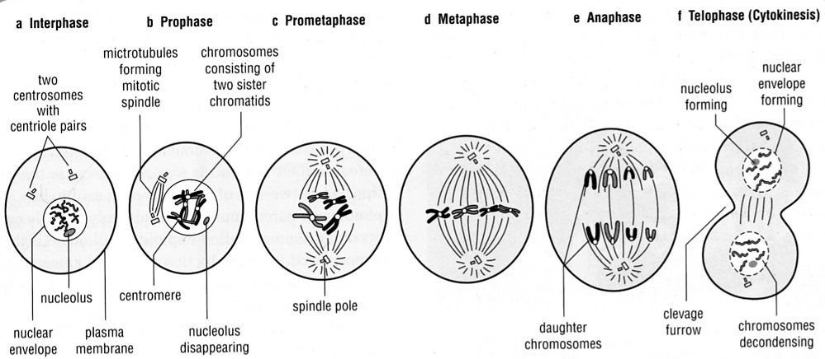
(a) Is this meiosis or mitosis?
(b) Describe what is happening at each stage to the chromosomes.
(c) If possible, name each stage.
(d) In which cells does this process occur?
(e) Draw a diagram to show the stages in the process not shown above.

7. (a) Why do cells undergo mitosis?
(b) Why do cells undergo meiosis?
(c) In what way do the cells produced by these two processes differ?

8. Polled cattle do not have horns. This is a dominant phenotype arising from the action of an autosomal gene P.
Horned cattle are therefore pp homozygotes.

(a) If a polled bull and a polled cow have a horned calf, what are the genotypes of the parents?
(b) If the same bull was bred with many horned cows, what would the proportions of polled and horned
offspring overall be? Show full working.

9. In Andalusian chickens, the black characteristic is incompletely dominant to the white-splashed characteristic.
The heterozygous (hybrid) condition produces blue chickens.

(a) How is incomplete dominance different to co-dominance?
(b) Determine the genotype and phenotype of the F1 generation from a pure-bred black Andalusian crossed
with a blue Andalusian.

10. The following pedigree shows the occurrence of no ear lobes in a family.

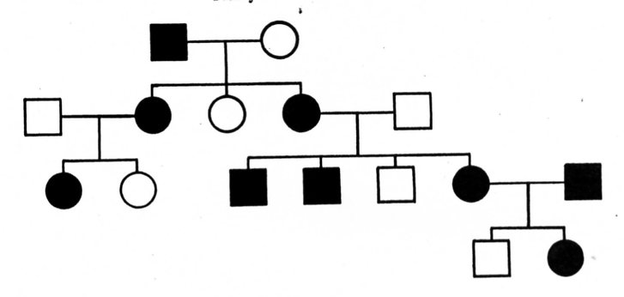

(a) Is the characteristic dominant or recessive (according to the pedigree)?
(b) Explain why you made that determination.
(c) Determine the genotype of every individual in the pedigree.
(d) How many females have no ear lobes?

11. Describe, with a simple diagram, the first stages of meiosis. Label what is happening at each stage.
In your diagrams, use 4 chromosomes as the normal number.

12. (a) How many chromosomes are found in a human skin cell?
(b) How many chromosomes are found in the reproductive cells?
(c) Name the process used to make reproductive cells?

13. (a) What is the difference between the male and female sex chromosome pair?
(b) Who determines the sex of a child - the mother or father? Explain.
(c) Show, by punnett square, why half of any particular population would be expected to
be female.
(d) A family has had five boys born into it, and the mother is pregnant with the sixth child.
What is the chance that the child will be a girl? Explain why.

Chemistry

1. (a) What is a group?
(b) Why are elements put into a particular group?
(c) What is a period?

2. Give a definition or description for the following terms.

(a) valence electron
(b) atomic number
(c) atom
(d) period
(e) atomic mass
(f) atomic number
(g) proton
(h) molecule
(i) element
(j) compound
(k) neutron
3. (a) In the diagram below, label the following groups of elements.

alkali metals, halogens, inert gases, transition metals

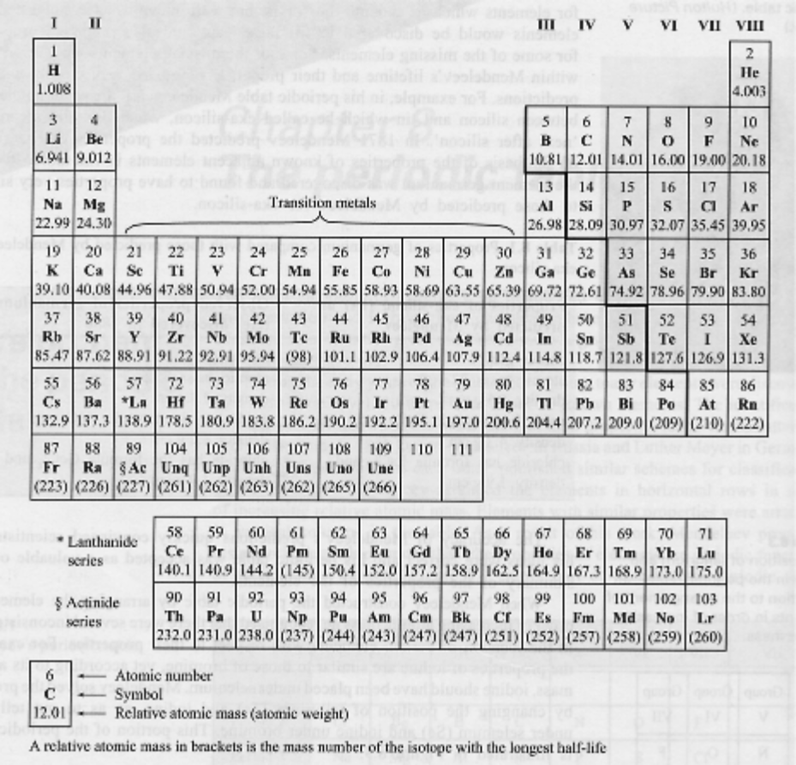

(b) What are the group numbers of:

(i) alkali metals?
(ii) inert (noble) gases?
(iii) halogens?

(c) Where do you find the non-metal elements? Show this on the diagram.

4. Complete the following table.

ELEMENT | PROTON NUMBER | NEUTRON NUMBER | ELECTRON NUMBER
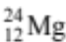
 | 17 | 18
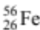
 |  | 14 | 13
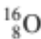

5. Write the name or symbol as required to complete the following table.

ELEMENT | SYMBOL
 | Ar
 | Pb
 | Ag
 | Si
 | Ni
 | S
 | O
 | Mn
 | Cl
 | He
ELEMENT | SYMBOL
aluminium
cobalt
tungsten
tin
carbon
copper
potassium
lithium
calcium
beryllium

6. Draw clear diagrams to show the electron configurations of the following elements.

(a) (b) 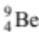 (c) 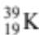 (d) 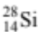

7. Look at the diagrams you drew for the elements in Q6. List which group they belong to. What do you notice
about the configuration and the group number?

